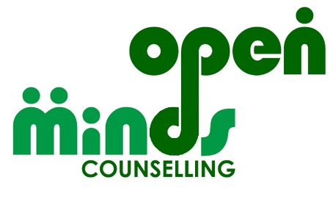
Counselling one to one and in groups for children aged 8 and over, and adults

We are a people friendly counselling service,
open to people of all genders, ethnicities, faiths, cultures, sexualities, neurotypes & disabilities

Children and Young People’s Counsellor
(1 post available, job share available)

14 hours per week at £14.49 per hour, open to job share

Permanent, subject to funding availability, to start 1st April 2023 and ends 31st March 2024 if funding not continued.

Working hours: Flexible, but predominantly out of School hours, including remote therapy on weekday evenings and in person therapy 9.30am – 3pm on Saturdays.

Open Minds Counselling Service is a successful mental health charity providing a range of services to help support people’s mental health recovery and wellbeing including counselling, peer support, training, volunteer development and information and guidance.

We are looking for a compassionate and resilient individual. You will be a qualified counsellor with 1 or more years’ experience of working with children and young people therapeutically and a good understanding of the needs of children and young people who have experienced psychological distress.

The administrative elements of your role will include submitting electronic notes in a timely fashion and following appropriate policies.

The support elements of your role will include a small case load of your own CYP clients. You may be asked to complete initial assessments of CYP.

For an application pack visit https://www.counsellingdoncaster.com/vacancies or if you need support to download an application please email hr@counsellingdoncaster.com

If you would like an informal discussion about this post, please contact Helen Mason, Managing Director on hr@counsellingdoncaster.com.

Your completed application form should be returned to: hr@counsellingdoncaster.com

Closing date: 5pm 27th January 2023
Interview date: Saturday 4th February 2023

